ERWY REPORT

Tiktok Data Analysis

JANUARY 15 – FEBRAURY 5

Total Followers Trajectory

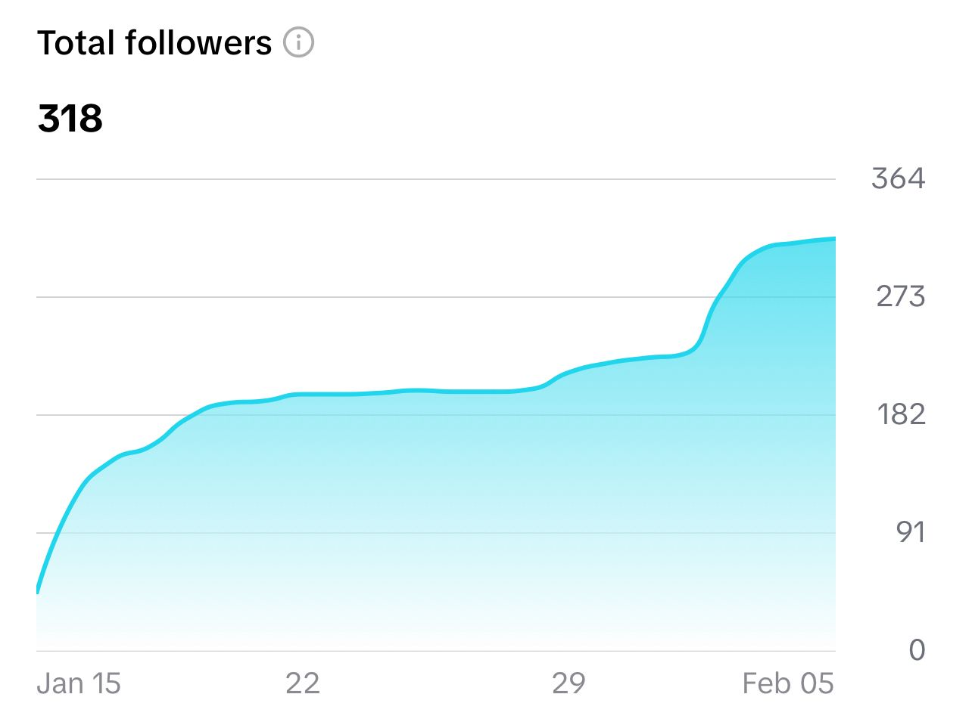

Followers Ages Trajectory

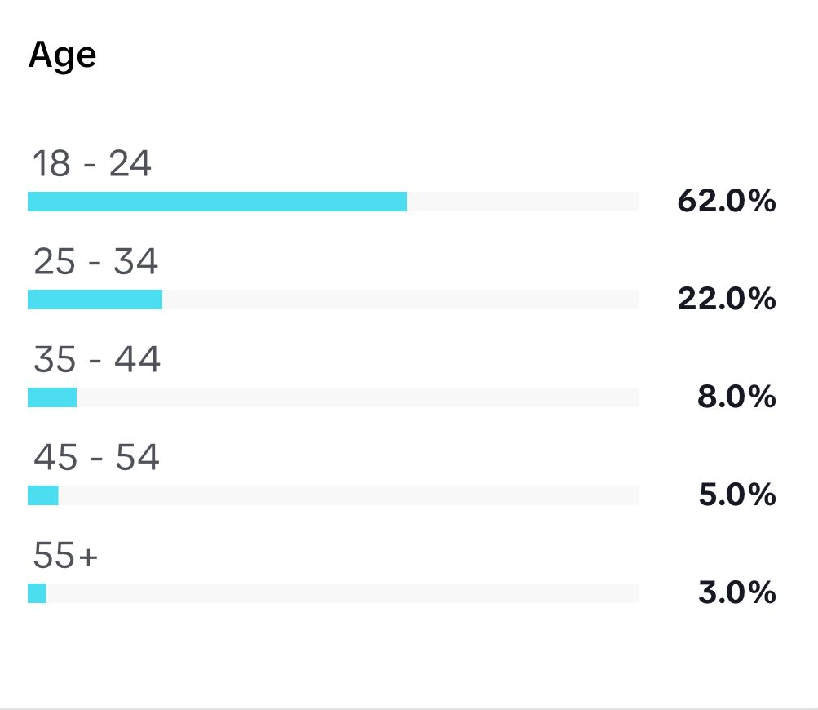

Followers Genders Trajectory

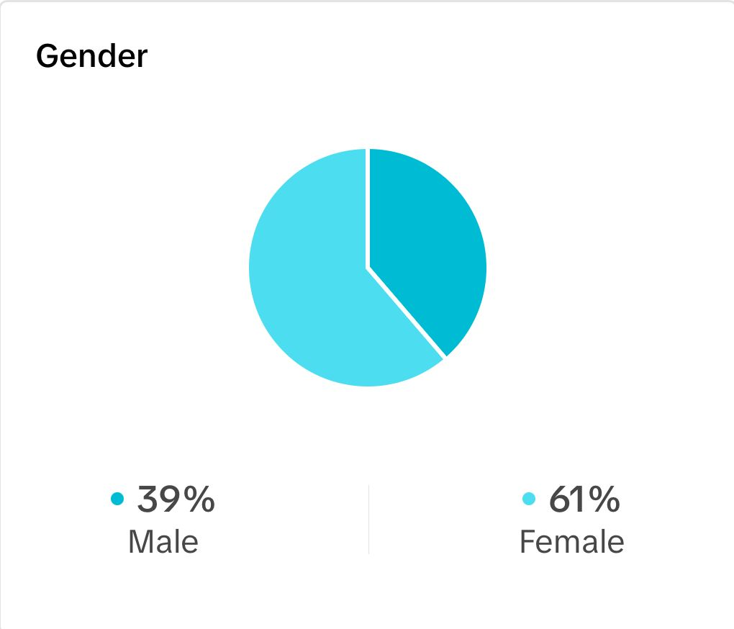

Followers Countries Trajectory

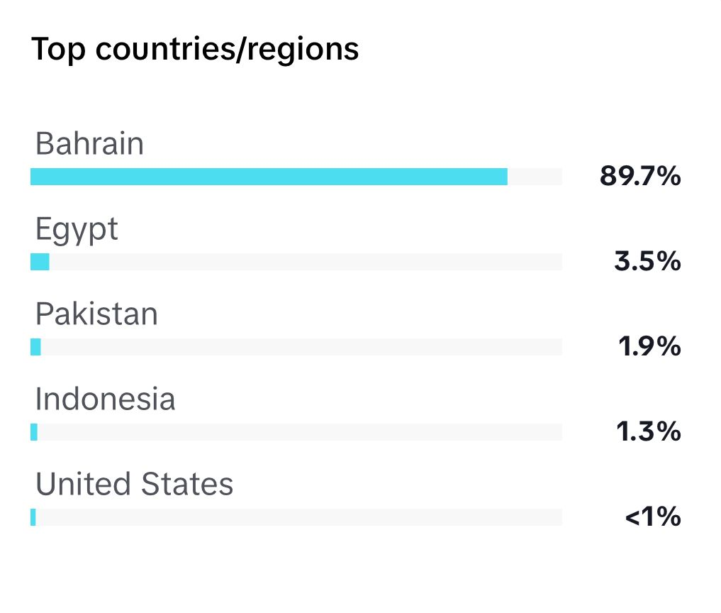

Profile views Trajectory

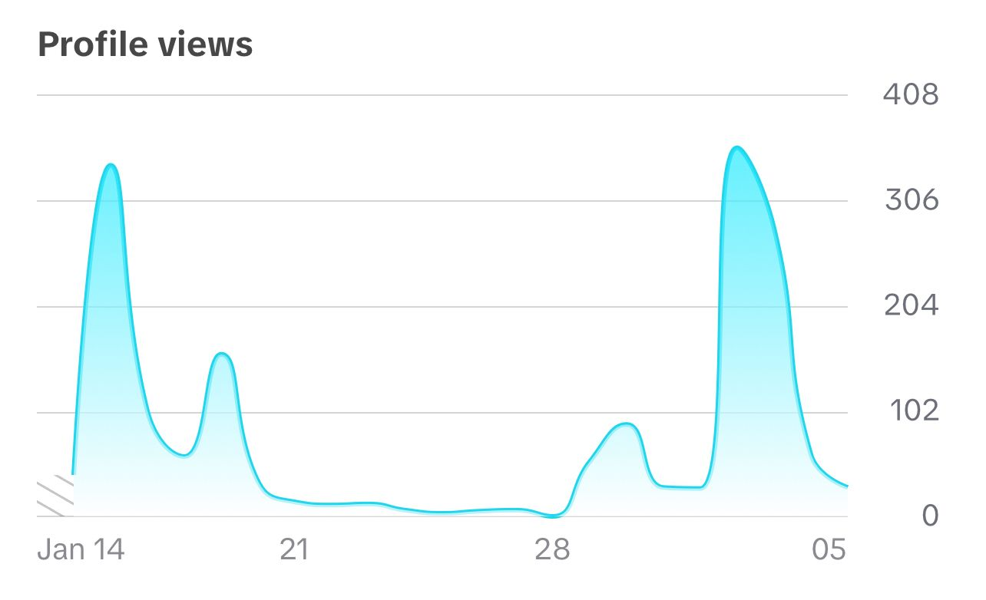

Video views Trajectory

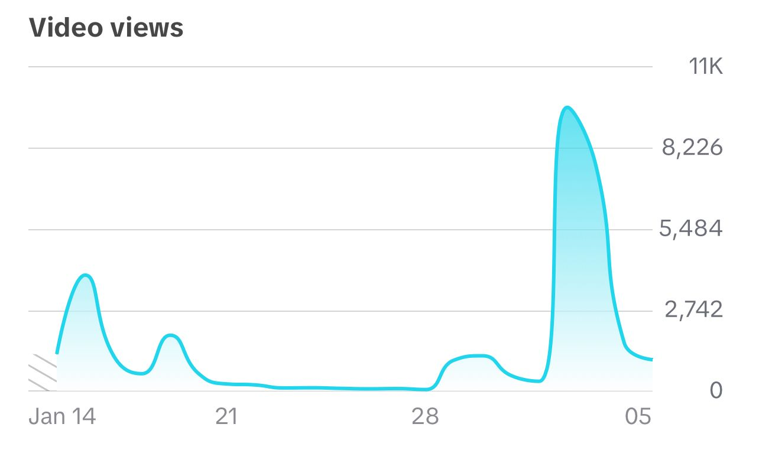

Likes Trajectory

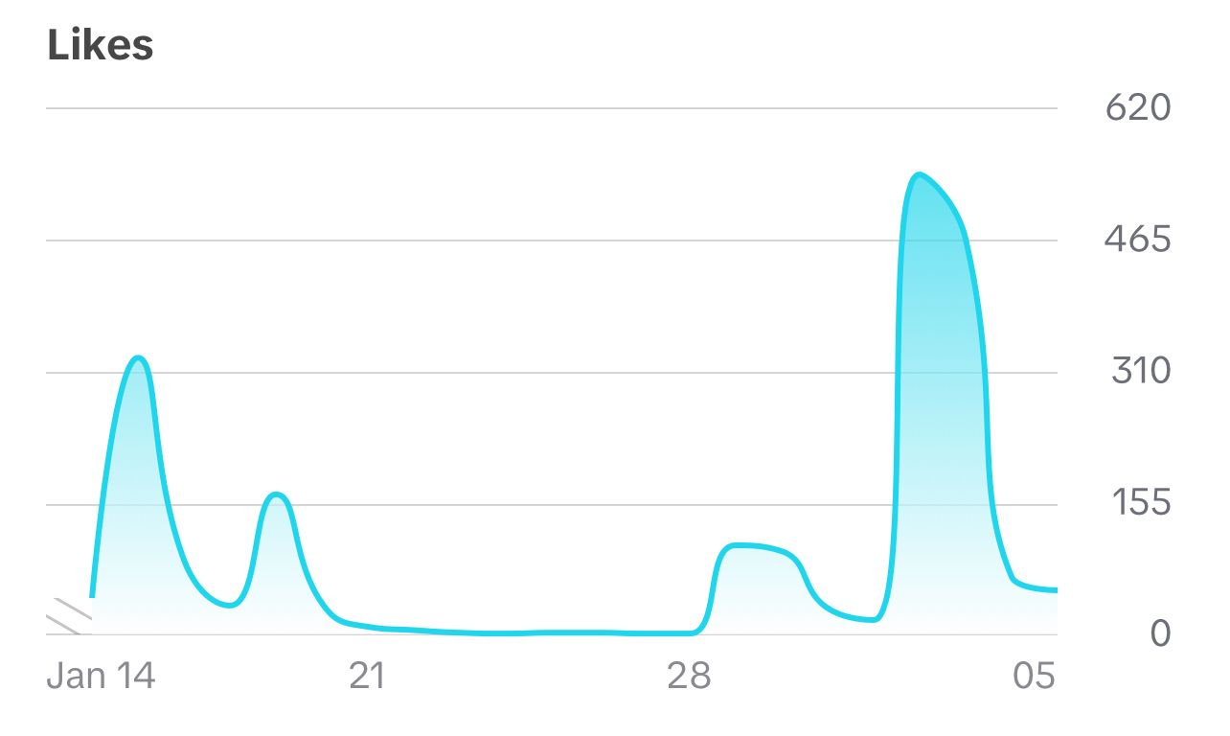

Comments Trajectory

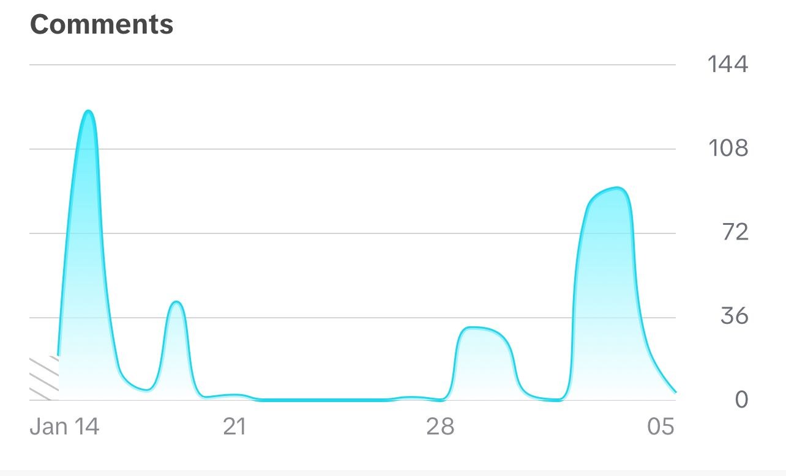

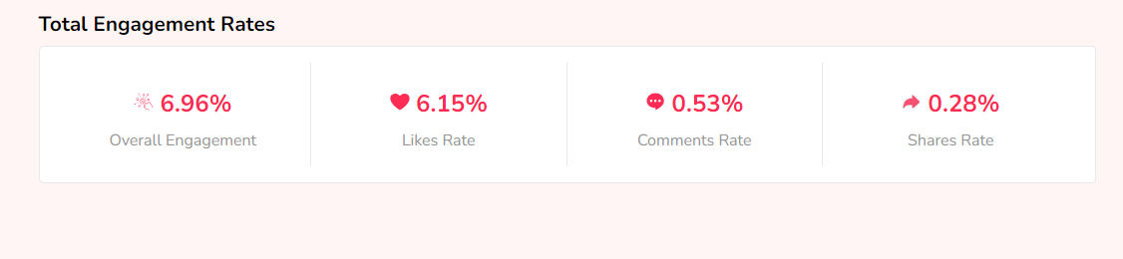

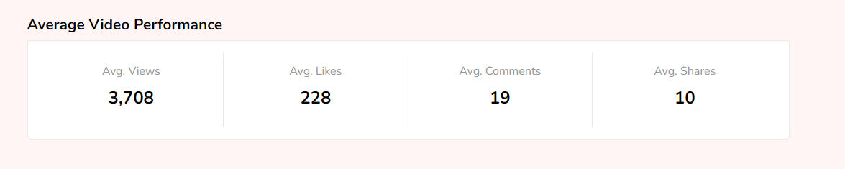

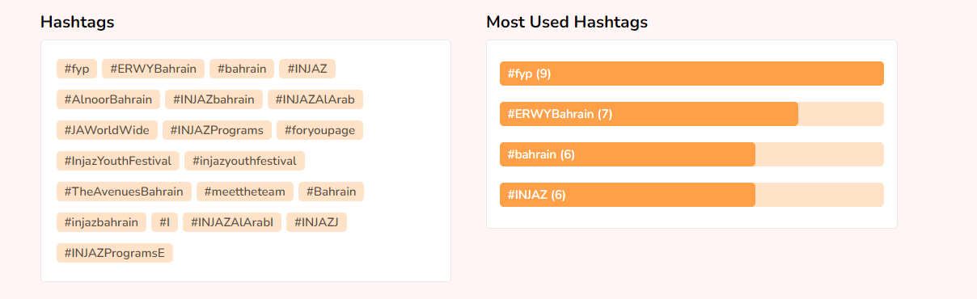

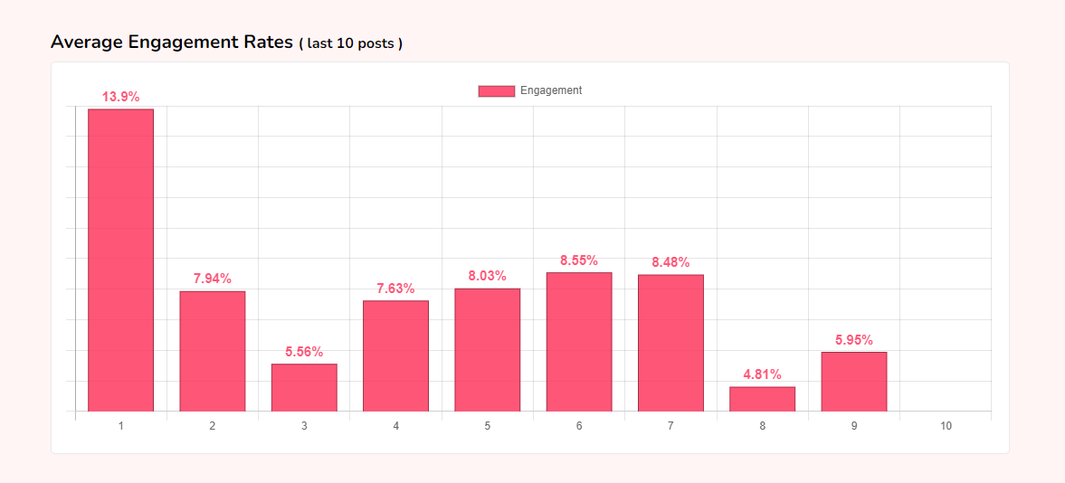

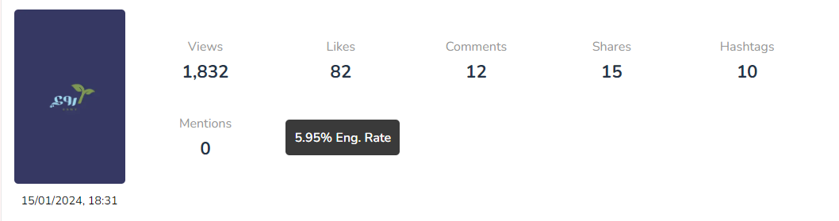

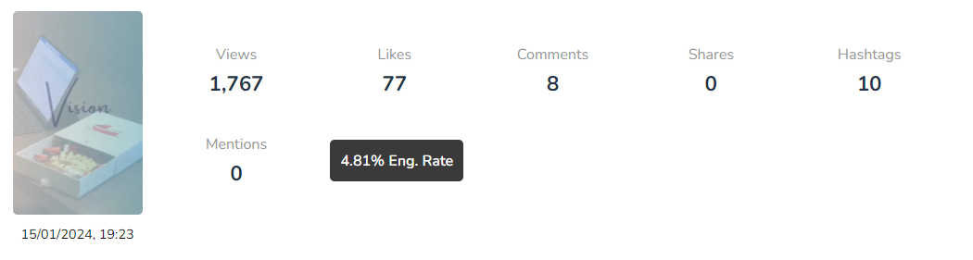

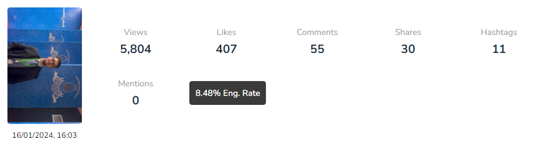

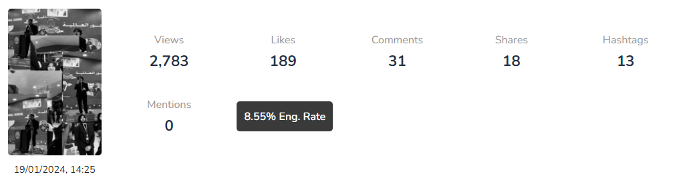

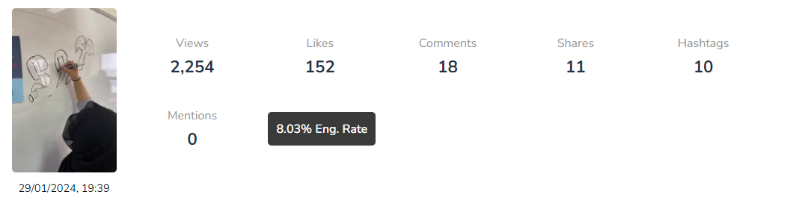

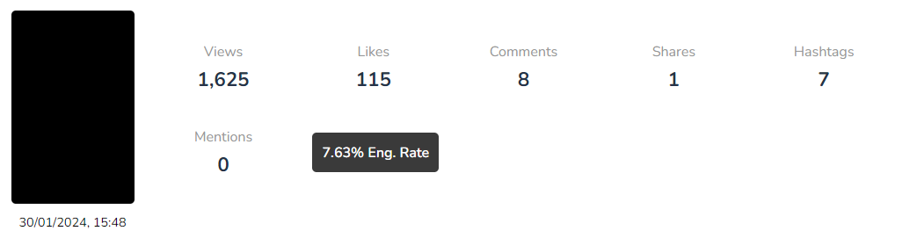

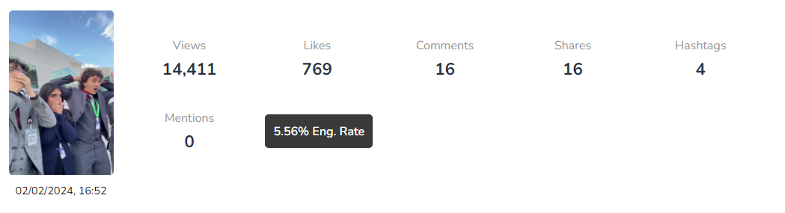

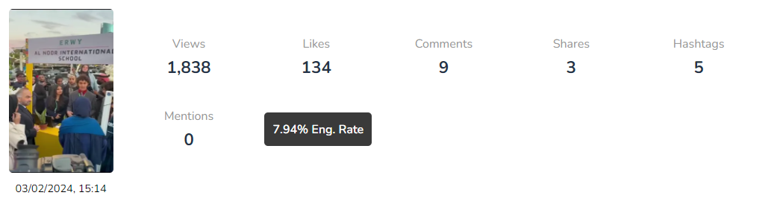

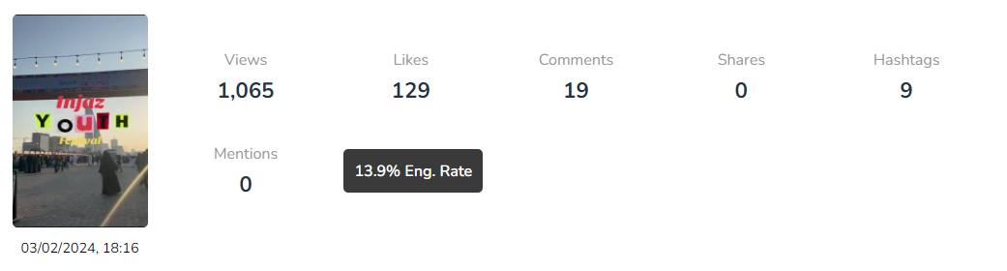

BEST TIMING TO POST

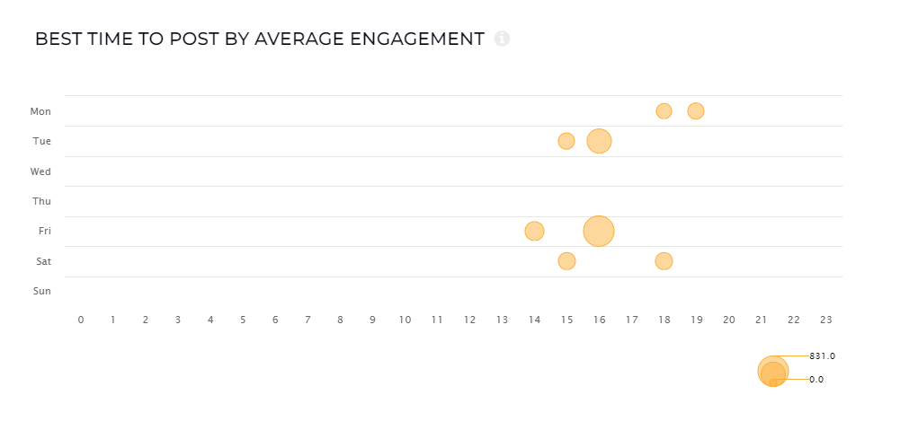

* **Best engagement was on Friday at 16:00**
* **Worst was on Monday 18:00 – 20:00**

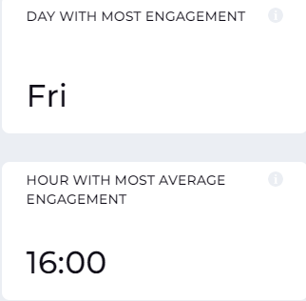

BEST HASHTAGS TO USE

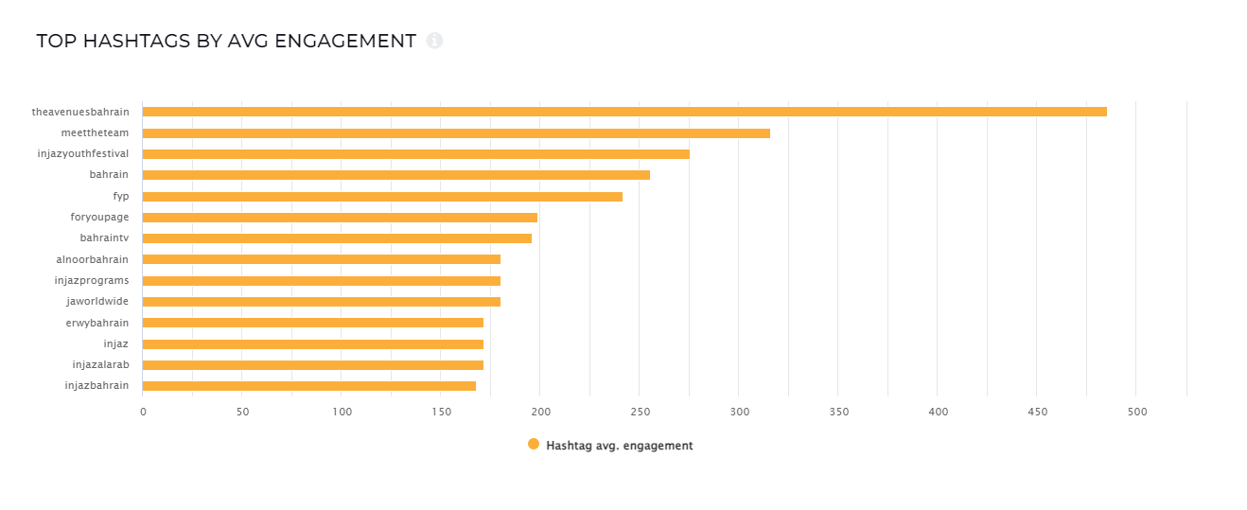

Ranking Of Hashtags To Use

